1. INTRODUCTION

VOF y interFOAM (condiciones verlo en el manual)

- Multifasico: para dos fases inmiscibles
- Incompresible
- Isotermico
- Turbulence

interFOAM: solver for 2 incompressible, isothermal immiscible fluids using a VOF

VOF: phase-fraction based interface capturing approach, with optional mesh motion and mesh topology changes including adaptive re-meshing.

Meshing Geometry

- Bisectriz: bisectriz de un angulo es la recta con origen en el vertice del angulo que lo divide en dos angulos iguales
- Eje de simetria: recta que divide una geometria en dos partes iguales
- Plano de simetria: plano que divide una figura tridumensional en dos figuras iguales pero reflejadas.
- Corte Axisimetrico : corte que tiene simetria de rotacion con respecto a un eje central.

GABRIEL PAPER

1)
For waste treatement water to be competitive:

- Provide effective wastewater treatment
- Generate high value-added products (single cell protein, fertilisers, hydrogen, poly-
hydroxyalkanoates (PHA) or pigments)

So they can balance their higher cost, specially in photobioreactors.

2) photrophic mediators → compounds that can use light as energy source for assimilative polluant removal
- Microalgae:
- Has promising results in terms of nutrient (N and P) removal and recovery efficiencies.
- Problem: if theres chemical oxygen demand (COD) in wastewaters, algae-based process result in the growth of non-phototrophic flankig organisms, generating in a mixed community commonly referred to as ALBAZOD (algae, bacteria, zooplankton, and detrius mixture) This reduces the COD and N recovery efficiencies and frequently results in predation by aerobic grazers.

Concepts:

* COD: chemical oxygen demand: necessary quantity of oxygen to oxide (oxidar) the organic and inorganic material in water through a strong chemical agent (ex: dicromato de potasio).
*Aerobic grazers: heterotrophic organisms that needs oxygen and that feed (comen) other microorganisms, such as bacteria and algae.

The predation (depredacion) of aerobic grazers can have a negative impact, due to their ability to consume algea, that leads to the decrease of the efficiency and affects the nutrient recovery.

- Purple phototrophic bacteria (PPB)
- Promising alternative, due to their ability to grow photoheterotrophically (foto hetetroficamente) when illuminated with near infrared (NIR) light under anaerobic conditions, assimilating simultaneously COD and nutrients (VENTAJA COMPARADO A LAS MICROOALGAS).

Characteristics PPB:

- Consisting mostly of purple sulphur and purple non-sulphur.

- Perform anoxygenic photosyntesis, using light as energy source and a range of electrons donors other than water.
- Under anaerobic illuminated conditions:
- PPB can grow autotrophically, with inorganic compounds as donors (ex: H2, H2S, So …)
- PPB can grow photoheterotrophy, using organic compounds (acetate, propionate, butyrate or malate) as donors.
- PPB can grow in the dark:
- Anaerobically via fermentation.
- Aerobically via respiration if oxygen is present.

*Anoxygenic: process that doesn’t produce oxygen.
*Anaerobic: process that takes place without oxygen.
*Aerobically: process that takes place with oxugen.

*Autotrophically: obtain light energy and can fix CO2 and use it as a source of carbon.
* Photoheterotrophically: obtain light energy but cannot fix CO2 by themselves. So instead of using CO2 they use organic compounds (fatty acids or carbohydrates) as a source of carbon.

- In wastewaters the pollutant removal occurs due to microbial uptake, which implies the adequate COD:N:P ratios in the wastewater are crucial to achieve complete nutrient removal.

* uptake: proceso de absorcion
* Non-sterile-conditions: environments where the removal of the present microorganisms is not completed, so it permits the growth of bacteria, fungus and other microorganims.

Sterile conditions | Non sterile conditions
Theres no microorganism (or only a small quantity) | There is microorganism in the atmosphere
Achieved trough autoclave, filtration or chemical agents | Extreme sterilization measures are not applied

3)

Most mechanistic models for PPB have been directed towards the prediction of hydrogen production via PPB.

Only one mechanistic model exists to represent wastetwater treatment and nutrient recovery by PPB: Photo-anaerobic model (PAnM)

PanM by Puyol (PONER BIBLIOGRAFIA)

- laboratory-scale performances in controlled environments (ex: constant artificial illumination and temperature, and fed with synthetic media).
- (LIMITACIONES) But in the future: mechanistic models applicable to future full-scale PPB-based processes must consider the complex nature of the waste streams to be treated, the varying environmental conditions that the reactor will be exposed to (ex: change in T and light intensity, day-night cycles etc) and potential synergies and competitions with other microorganisms.

Para recurrir a las limitaciones y los avances que se hacen al dia de hoy:

ePAnM:

- Detailed mechanistic model applicable for mixed PPB cultures grown outdoors, as an extension of the PanM model (el e de ePAnM indica extension).

Includes:

- Relevent microbial clades interacting with PPB (ex: aerobic heterotrophs, acidogenic and acetogenic fermenters, aerobic predators, heterotrophic and autotrophic sulphate reducing bacteria (HSRB and ASRB) and microalgae).
- PPB metabolism has been extended, including fermentative, aerobic, chemoheterotrophic, and photoautotrophic growth.
- Inhibitory effect have been added, including the effect of oxygen or acid/basic pH values on phototrophic metabolisms. To do so:
- Main phisico_chemical processes also have been considered (ex: speciation and chemical equilibria of many species, or gas-liquid mass transfer).
- Impact of varying temperatures and light intensities on PPB growth rate also been included.
- Model was demonstrated using data for different operational periods for a demonstrative-scale flat plate reactor and with batch tests.

* Microbial clades: groups of microorganisms that share a common ancestor according to their genetic evolution.

Model description:

- Monod kinetic → used in limitating or inhibitory expressions.
- Anaerobically, both photoheterotrophic ( using VAFs [acetic acid or other VFA] as electron donors) and photoautotrophic (using molecular hydrogen or hydrogen sulphide) as electron donors.
- Aerobic capabilities of PPB were included
- Aerobic heterotrophic biomass was included as main PPB competitors under the presence of oxygen.
- Aerobic conditions were included for two reasons:
- strong inhibition of the phototrophic capabilities of PPB by oxygen
- The potential relevance of alternate anaerobic/aerobic processes in PPB technology.

- Microalgae were included to consider potential phototrophic competitors, as well as combined processes where both PPB and microalgae could coexist
- To separate microalgae from PPB growth, the model considered two different lights input:
- visible (VIS) wavelengths
- NIR wavelengths

4) Summary

The PanM considers PPB as single biomass, including their fermentative and phototrophic capabilities and assuming constant environmental conditions.
The ePAnM considers many other biomass components, processes, inhibitory factors, and varying environmental factors. All described below:

4.1. Components, processes, and inhibitory factors:
ePanM consists of 21 components (plus 7 to consider ionic equilibria and CO2 desortion) , 30 biochemical processes and 8 inhibition factors.

* Inhibition: process in which activity is stopped or slowed down.

4.2 hanging environmental conditions: influence of light intensity,
temperature, and pH

Need to see the equations in the article.

4.3 Model limitations

- Nitrification and denitrification have been omitted , because the reactors are expected to be operated with excess organic carbon, and generally oxygen limited conditions.
- Uptake of nitrates and nitrites by microalgae has also been omitted, considering only ammonia-N as N source for algae growth.
- The generation of gases other than CO2 has not been considered, even tough having most systems for outdoors PPB growth are expected to be open to the atmosphere
- Production of hydrogen and methane have been omitted
...

2. MODELO

ARICULO 1: A computational model for transport of immiscible scalars in two-phase flows.

1)
Propose:
- Scalar-transport model for the simulation of scalar quantities in two-phase flows with phase-field method (diffusive-interface method).

- Typically the scalar quantities have disparate properties in two phases, which result in effective confinement or immiscibility of the scalar quantities in one of the phases.
- Confinement of scalars leads to the formation of sharp gradients of the scalar concentration values at the interface, PRESENTING A SERIOUS CHALLENGE FOR ITS NUMERICAL SIMULATIONS USING SHARP-INTERFACE METHODS.

To overcome this challenge:
- computational model for the transport of scalars using diffusive interface strategies while maintaining the immiscibility condition for these quantities. Model is discretized using a central-difference scheme.
- Strength of the model:
- Model maintains the positivity property of the scalar concentration field
- The transport of the scalar concentration field is consistent with the transport of the volume fraction field → enforcement of the zero-flux boundary condition → avoids artificial numerical diffusion across the interface
- Wide range of two-phase flows regimes: spanning laminar to turbulent flows

*Example of scalar quantities: temperature, concentration, pressure, phase fractions
* Immiscibility: property were two substances are not capable of combining to form a homogeneous mixture.

2)

- Worst case scenario: the diffusivities in the two phases could be so different that the ratio of diffusivities in two phases could tend to infinity.
The disparate properties of the scalar quantities in different phases result in scalars effectivity being confined to one of the phases in the time scales of interest.
→ Challenge to resolve the gradient of scalar concentration at the material interface
→ Leads to numerical leakage (artificial numerical diffusion) at the interface and negative values of the scalar concentration field.

-
Advantages:
Diffusive-interface method (phase-field method) | VOF
- Absence of geometric reconstruction of the interface that results in a low-cost, load-balanced, and a highly-scalable method | - More accurate on grids of same size

VOF usa reconstruccion geometrica para definir la interfaz (traza lineas o superficies que separan las fases), mientras que la interfaz difusa no usa geometria (lo que baja su costo computacional), lo hace mas rapido y escalable.

Comparisons
Per-costs basis: both VOF and diffusive-interface method are known to perform similarly for incompressible two-phase flow.
Level-set-method: diffusive interface method also maintains discrete conservation of volume of each of the phases

-
Most VOF methods tackle the issue of artificial numerical diffusion of the scalar across the interface by geometrically advecting the scalar concentration field in a manner consistent with the advection of the volume fraction.
However, difussive-interface method, advection of the volume fraction field is performed non-geometrically with the use of finite-difference schemes (factor that reduce the cost and improve the scalability of the method compared to VOF). But the lack of geometric fluxing in diffusive-interface method poses a challenge towards modeling scalars and to prevent numerical leakage of the scalar across the interface.

3)

First step to simulate scalars in two-phase flow is to choose an interface-capturing method that can accurately simulate interfaces in challenging environments:

Phase-field, for the reasons described earlier

ARICULO 2: On comparison of the sharp-interface and diffuse interface level set methods for 2D capillary or/and gravity induced flows.

1)

Comparison of numerical-methodology as well as performance of the two types of level set methods (LSMs):
- sharp-interface
- Diffuse interface.

Numerical-methodology along with mathematical-formulation are presented in-detail for:
- Sharp-interface level-set-method (SI-LISM)
Compared with:
- Traditional diffuse-interface level-set-method (SI-LSM)
- Improved diffuse-interface dual-grid-level-set-method (DI-LSM)

2)

Types of numerical methods for tracking the interface location and capturing its dynamics:
- Eulerian method
- Lagrangian method

2.1)) The former method (LAGRANGIAN)
Front-tracking method: involves tracking of interface on the grid points as front. (Ref 1996)
- The interface is tracked by the motion of particles on the interface
- Interface is located explicitly with accurate calculation of curvature. However, it requires special modeling for capturing the interfacial dynamics like merging and break-up.

2.2)) The latter method (EULERIAN)
Front-capturing method: capturing the interface on a fixed grid (such as volume of fluid, phase-field method, and level set method)
Captures the interface explicitly, with an additional scalar field.

- VOF
- Interface is treated as a step-wise function and reconstructed by volume fraction values.
- Geometric method is used to reconstruct the interfacial topology at each time step which make it difficult to extend from 2D to 3D.
- Phase field
- Considers the interface with finite width(diffusive-interface) which is small compared to the smallest length of the domain.
- Captures complex interfacial shapes. However, the results are dependent on the interface thickness and the mesh.
- Level-set-method (LSM)
- Interface is captured implicitly and can be easily extended to higher-dimensions.
- Biggest disadvantage: mass conservation error due to reinitialization required at every time-step.

EL RESTO DEL ARTICULO ES SOBRE LSM

LIBRO (THESIS): A NOVEL DIFFUSE INTERFACE METHOD FOR TWO-PHASE FLOWS
AND APPLICATION IN SIMULATION OF MICRO-BUBBLE ENTRAINMENT

Aclaraciones:

Two phase flow: Se refieren a sistemas donde dos fases distintas coexisten y fluyen simultáneamente
Two scalar: se centran en la evolución de dos cantidades escalares independientes, que pueden o no estar asociadas a diferentes fases

1) Definition of two-phase flow

Gas liquid multi-phase flows are simply known as two-phase flow.

Two-phase flow refers to the interactive flow of two distinct phases (each phase representing a mass or volume matter) with common interfaces in a channel. Two-phase flow can occur in a single-component or a multicomponent system. Possible phase combinations include: (a) solid-liquid, (b) solid-gas, (c) liquid-vapor(gas), (d) combination of the above.
(Ref: Two-Phase Flow - an overview | ScienceDirect Topics [WWW Document], n.d. URL https://www.sciencedirect.com/topics/engineering/two-phase-flow (accessed 3.10.25).
(REFERENCIA ES UN LIBRO)

2)
The interface-capturing approaches are preferred nowadays (to the tracking interface) due to their automatic treatment of topological complexities.
- VOF
- Level-set schemes
- Phase field (diffuse interface):
- Advatages: simplicity, parallel-scalability, ease of surface tension force calculations and desirable mass conservation properties.
- Traditional phase field methods are based on either Cahn-Hiliard or Allen-Cahn method.
- But nowadays they have combines both and introduced a second order, conservative phase-field equation.

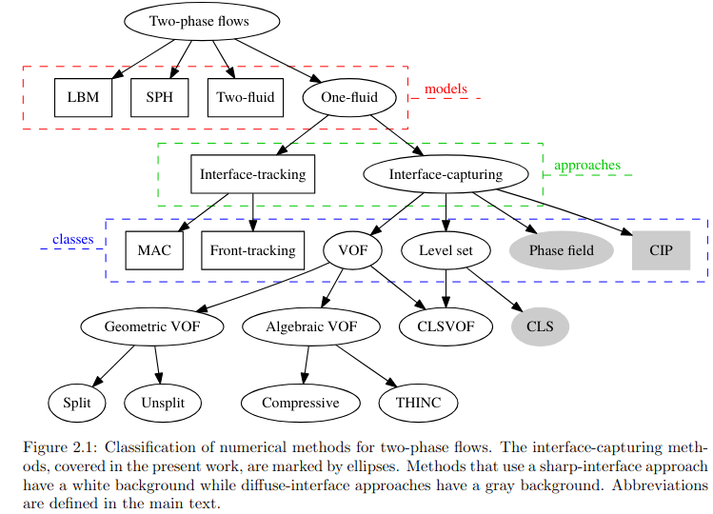

DTU DATABASE : Performance of interFoam on the simulation of progressive waves
https://www.tandfonline.com/doi/full/10.1080/21664250.2019.1609713
https://backend.orbit.dtu.dk/ws/portalfiles/portal/200649194/interFoamInterFlow_accepted.pdf

En interFoam la interfaz se representa mediante la variable de fracción de volumen (α), que varía de 0 (una fase) a 1 (la otra). Debido a la forma en que se resuelve la ecuación de advección para α y al uso de esquemas numéricos (incluyendo el método MULES para limitar oscilaciones), la transición entre fases se extiende sobre varias celdas, generando una interfaz difusa en lugar de una línea o superficie perfectamente nítida.
Según el documento, la interfaz en interFoam se representa mediante la variable de fracción de volumen (α), que varía de 0 (una fase) a 1 (la otra). Varios aspectos del método contribuyen a que la interfaz aparezca como “difusa”:
- Discretización de la ecuación de transporte de α:
La ecuación de advección para α se resuelve usando el método de volúmenes finitos. Debido a la interpolación de los valores (por ejemplo, mediante esquemas lineales o TVD) y a la naturaleza de la aproximación numérica, la transición de α entre 0 y 1 se extiende sobre varias celdas, en lugar de ser una discontinuidad abrupta.
- Uso del algoritmo MULES:
Para garantizar la acotación (boundedness) de la variable α, se emplea el algoritmo MULES (Multidimensional Universal Limiter for Explicit Solution). Este método limita las oscilaciones pero, a la vez, introduce una cierta difusión numérica que contribuye a que la interfaz se “esmolezca” sobre varias celdas.
- Término de compresión de la interfaz:
La formulación original de la ecuación de transporte de α se extiende mediante la adición de un término compresivo del tipo
∇⋅(α(1−α)ur​)
que intenta “comprimir” la interfaz para mantenerla más nítida. Sin embargo, la eficacia de este término depende de la elección del parámetro de compresión (cα) y de las condiciones numéricas (por ejemplo, el tamaño del paso temporal y la resolución de la malla). Si estos parámetros no se ajustan de forma óptima, el término compresor no logra contrarrestar completamente la difusión inducida por la discretización, y la interfaz permanece extendida (difusa).
- Influencia de la resolución espacial y temporal:
El grosor aparente de la interfaz depende directamente de la resolución de la malla y del paso temporal (controlado mediante el número de Courant). Una malla más gruesa o un paso temporal elevado aumentan el ensanchamiento numérico de la interfaz, mientras que una malla fina y pasos pequeños pueden reducirla, aunque nunca la hacen infinitamente delgada.
En conjunto, estos elementos –la forma en que se discretiza y resuelve la ecuación de α, el uso de MULES, el término de compresión y la dependencia de la resolución– generan en interFoam una interfaz que, en la práctica, se extiende a lo largo de varias celdas en lugar de definirse de forma “aguda” o perfectamente nítida.

TO UNDERSTAND BETTER THE PHASE FIELD METHOD:

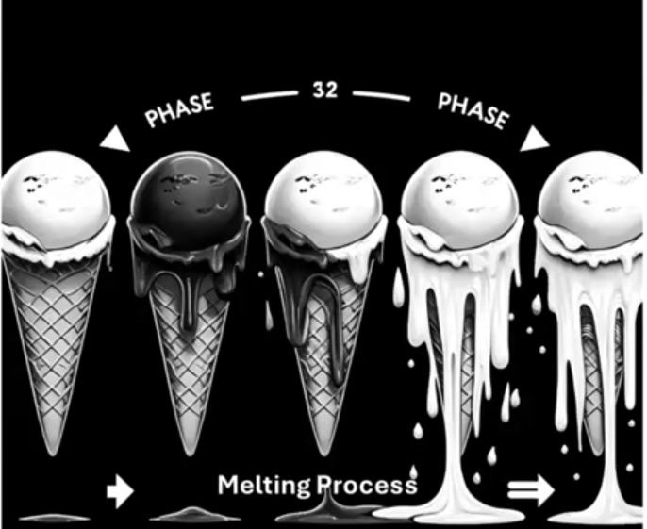

En phase field no sabemos donde esta la interface, aqui en el calentamiento del helado no sabemos exactamente en que punto se pasa de solido a liquido, por lo que, la interface es difusa.

1. Phase field method: https://www.researchgate.net/publication/233496961_Phase_field_method

Example: growth of a precipitate which is isolated from the matrix by a interface-capturing

There are three distinct quantities to consider; the precipitate, matrix and interface
- Interface: evolving surface whose mention is controlled according to the boundary conditions with the mechanics of transformation

SHARP INTERFACE:

The interface in this mathematical description is simply a two-dimensional surface with no width or structure. (interface esta en un punto definido no tiene ni ancho ni estructura).

PHASE FIELD METHOD:

The state of the entire microstructure is represented continuously by a single parameter ϕ .
- ϕ = 1 represent the precipitate.
- ϕ = 0 represent the matrix.
- 0 < ϕ < 1 represent the interface.

So the interface is located by the region over which ϕ changes from precipitate-value to matrix-value.
The range over which it changes is the width of the interface.

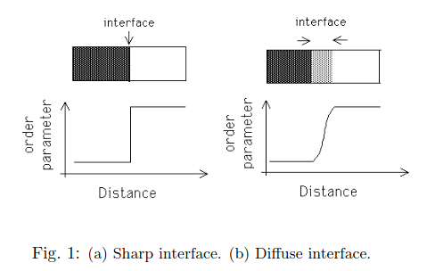

2. Differences between sharp and diffused interfaces. Ref: https://www.researchgate.net/post/What_do_we_mean_by_sharp_and_diffused_interface_model_in_the_context_of_multiphase_flows

In context of multiphase flow sharp and diffused interface refer to how the boundary (interface) between two phases (ex: liq and gas) is represented in numerical models.

Sharp interfaces Models:

The interface between two phases is represented as a well defined-boundary, with a discontinuity in properties like density and velocity at the interface(indicando que por ejemplo la densidad pued cambiar de 100 kg/m3 a 1.2). This approach directly captures the location of the interface and the flow behavior on both sides.

The main challenge with sharp interface models is the difficulty in capturing complex interface dynamics (like surface tension or instability) without introducing computational costs or inaccuracies de to the sharp transition between phases.

Characteristics:

- Clear delineation between phases.
- Interface explicitly tracked or captured.
- Computationally more demanding when resolving interface evolution, especially for complex geometries.
- Can handle interface phenomena (like surface tension more directly).

Diffusive interface model:

The interface between two phases is represented over a finite region (Es decir con ESPESOR, mirar punto de arriba), rather than being sharp. Instead of modeling a clear boundary between phases, these models use continuous fields (ex: phase field) that gradually transition between phases. The interface is typically a region where properties (ex; concentration, temperature, …) change smoothly over a small but finite region. (VENTAJA: puede ser una ventaja que no haya cambios brutos de propiedades).

Characteristics:

- Simpler to implement
- No explicit tracking of the interface is needed; it is embedded in the solution.
- Better suited for modeling complex topological changes (like merging or breakup of phases).
- Less accurate in capturing the precise interface positions.

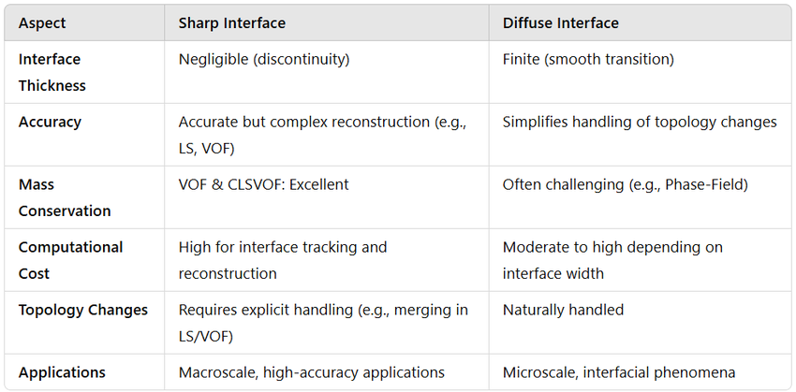

ARTIFICIAL NUMERICAL DIFFUSION (NUMERICAL LEAKAGE)

La difusión numérica artificial es un fenómeno que ocurre en las simulaciones de dinámica de fluidos computacional (CFD) cuando el método numérico introduce una difusividad mayor que la presente en el sistema físico real. Esto provoca una suavización excesiva de los gradientes en campos como concentración, temperatura o velocidad, afectando la precisión de la simulación. Este efecto es común en métodos de diferencias finitas o volúmenes finitos y puede ser particularmente problemático en simulaciones donde se espera que el sistema no exhiba comportamiento difusivo.

2. MODELO FEEDBACK AND MORE (NO LITERATURE)

- Original ePAnM model (only dependence on time), no considera variaciones espaciales, sino solo como cambian con el tiempo.

dA/dt​=f(A), solo depende del tiempo (verificarlo)

But this ePAnM model with diffuse interface, implements transport equation and diffusive interface.

Ahora tambien se incluye el termino de adveccion, difussion y el termino fuente. El termino fuente ya estaba en el ePAnM original, en nuestro modelo implementado se anadieron la difusividad y la adveccion, y ahora cada variable de

-Alpha and psi NO dependen del tiempo.

- “The ePAnM model is built upon a set of transport equations to describe the interface between these phases”

Frase de arriba falsa, El ePAnM model solo considera el tiempo como variable independiente. La adaptacion de las ecuaciones de transporte forma parte del trabajo.

- “ePAnM assumes steady state bubble and velocity distribution”

Parte subrayada tambien es falsa, pero si parte del proyecto esta descrito con esta assumption.

- Order of explanation (prior to anything related to figure Y):

1. Start with the the gas transfer through bubble interfaces

With the support of equation 3, 4, 5 and figure Z

2. To make it easier add figure X (diffuse interface) and plots fig Y (alphaSH2 and alphaH2gas)

This way, it will be much easier explain why the reaction term banishes far from the interface.

CASO UNIDIMENSIONAL

Lo hice con una adveccion positiva U =(1e-5 1e-5 1e-5), es decir que la direccion es a la derecha

- Si U < 0 Direccion adv izquierda.
- Si U > 0 Direccion adv derecha.

Conclusions

- Pc not for this kind of simulations. In the one-dimensional (100 cells), it took 2 hours and 48 minutes to generate 25 hours of simulation time, with 1e-3. (Indicates the low computer power)

- We suspect that in all cases where we obtained the ‘floating point error’ was due to the low computational power.

- There were no numerical leakage, but generation of negative values due to the presence of alpha values superior to 1 and some negatives, which are physically incorrect.

- This project requires more “investigation” , with a more powerful computer to obtain the results

- Concluded that not one post-proccesing utility worked to execute the biological model
Data transfer (utilities) led to very bad results.
Mesh-proccessing: conducted to error floating point exception.

- We developed a GUI, that permits to execute with only a click the biological model, also allowing the change of their physical properties and ploting the results obtained.

The ePAnM- two scalar with a diffuse interface was successfully ran for the created one-dimensional mesh, but took 2 hours and 48 minutes to generate 25 hours of simulation time, with the 1e-3 as a time step, showing the low computational power of our computer.
In the compartment model generated, the simulation led to non physical values due to the presence of negative and values superior to 1 in alpha. When increasing the time step to 1e-3 a ‘floating point error’ emerged. We suspect that is also due to the low computational power of our computer. Further essays should be done with more powerful computers to confirm these supositions.

Also, we developed a GUI so that users can execute ith only a click the biological model, also allowing the change of their physical properties and ploting the results obtained, for any OpenFOAM case.

Conclusions
The ePAnM-two scalar model with a diffuse interface was successfully run on the one-dimensional mesh created. However, the simulation took 2 hours and 48 minutes to generate only 25 hours of simulation time with a 1e-3 time step, highlighting the low computational power of our system.
In the compartment model, the simulation resulted in non-physical values, with alpha values exceeding 1 and some negatives. Increasing the time step to 1e-3 led to a floating point error, which we suspect was also due to limited computational resources. Further tests with more powerful hardware are necessary to confirm these assumptions.
Additionally, we developed a GUI that allows users to execute the biological model with a single click, modify its physical parameters, and visualize results, making it compatible with any OpenFOAM case.
Post-processing utilities failed to execute the biological model properly, and data transfer utilities led to poor results. Moreover, mesh-processing operations resulted in floating point errors. These issues indicate the need for further investigation and improved computational tools.

